

**OIKOS VERITAS SERVICES LTD.**

**ECOLOGY⎮ECONOMICS⎮ENVIRONMENT**

**CONSULTANTS**

**Home**

**About us**

**Photos 1, 1.x…..**

The name ***Oikos*** has roots in the two English words “*ecology*” and “*economy*” and the Latin word "*veritas*,” signifying light and truth. **Oikos Veritas Services Limited** (**OVS**) is incorporated in Kenya as an independent consulting firm in the fields of ecology, biodiversity, environment, economics, energy, occupational safety and health, and social sciences. Our experts are drawn from a network of experienced professionals accredited by different professional organizations. Our proven track record has qualified us as a consulting firm in eastern Africa.

We are committed to improving the ecological, environmental, and socioeconomic well-being of the present and future generations by providing innovative and high-quality consulting, advisory, and capacity development services.

**Our expertise**

* Environmental assessments
* Ecology and biodiversity
* Resource economics
* Water and sanitation
* Energy
* Occupational safety and health
* Eco-tourism and leisure
* Projects development, monitoring and evaluation
* Eco-business enterprise development
* Mining and mineral exploration
* Documents reviews and editorials

**Our geographical scope**

We operate from our offices located in Nairobi and affiliate offices across Kenya in Marsabit, Isiolo, Turkana, Mandera Counties, and London (United Kingdom) to serve clients in Kenya and Africa.

**Certifications/affiliations**

Registered/Practicing NEMA Lead EIA/EA Firm No. 6931, Kenya

Corporate Member No. 2000140, EIK, Kenya

Coalition for European Lobbies on Eastern African Pastoralism (CELEP)

Ecological Society for Eastern Africa

**Services**

We offer multi-disciplinary professional consulting and advisory services with quality deliverables inspired by innovation and creativity in ecology, biodiversity, environment, and economics. Our services are provided by teams of experienced professionals with proven track records gained through working with a range of private and public sector organizations.

**Environmental assessments**

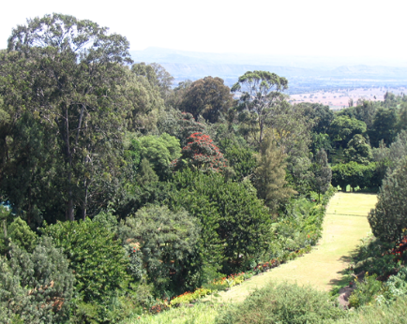We offer a comprehensive range of environmental services, including Environmental Impact Assessments (EIA), Environmental Audits (EA) and Strategic Environmental Assessments (SEA), across different sectors, supporting public and private entities to adopt best environmental practises in their operations and ensure compliance with the existing national and international regulatory guidelines. Our environmental assessments and audit services focus primarily on the assessment of the consequences (positive and negative) of projects on the environment prior to the decision to move forward with proposed actions. We apply best methodologies that are tailored to meet environmental management expectations and ensure compliance with the existing regulatory requirements. We undertake due diligence to help organizations meet the environmental and social safeguard standards for financial institutions, including the WB, IMF, EIB, and AfDB. We specifically offer key environmental assessment and audit services in the following key sectors:

* Agriculture, livestock and fisheries
* Agroforestry
* Built environment
* Energy
* Healthcare
* Mining
* Transport infrastructure
* Tourism
* Water and sanitation

**Ecology and biodiversity**

We offer pragmatic, reliable, and turn-key resource ecology and biodiversity consulting services that balance conservation and development needs in terrestrial and aquatic ecosystems. Our integrated approaches employ cutting-edge methodologies and standard application procedures to produce robust and practical sustainable solutions that work with nature and biodiversity, allowing clients to meet national and international guidelines such as IFC-PS6, WB-ESS6, AfDB OS on biodiversity and ecosystems, and the requirements of other financiers such as EDFI.

**Specialties**

* Baseline studies on species and habitats
* Biodiversity conservation action planning
* Climate change studies, adaptation and resilience
* Ecological research projects development
* GIS and remote sensing
* Invasive species assessments
* Land use and cover assessments
* Landscape ecology spatial planning
* Problem animal control in aviation sector
* Protected species surveys and targeted studies
* Resource inventories, mapping and action planning

**Resource economics**

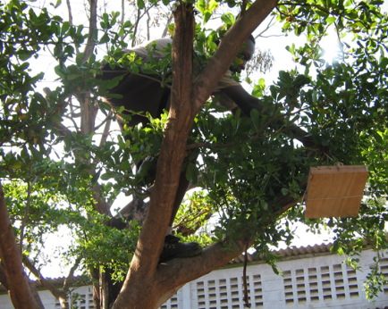Our resource economics consulting services focus on providing a better understanding and application of economic (micro and macro) principles to natural resource management. We analyse and explain interactions between economics and resource use with the goal of developing a sustainable and efficient economy.We focus on addressing the socioeconomic impacts of actions related to the use of resources and to better understanding the role of such resources in economic development. We integrate economics and environmental expertise with exceptional abilities to provide critical answers to complex relationships between economics, resource use, and decision-making.

**Specialties**

* Agriculture and rural development
* Economic impacts analyses
* Eco-tourism development and products pricing
* Energy, water and sanitation studies and planning

**Water and sanitation**

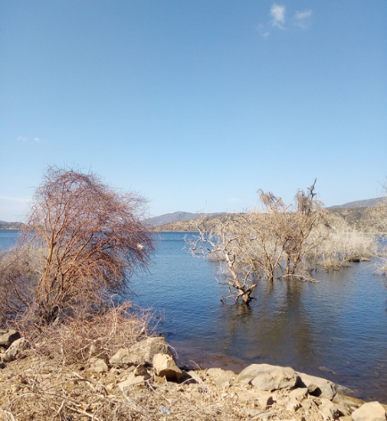Clean drinking water, hygiene, and sanitation play an important part in maintaining health. Access to clean water and sanitation facilities is increasingly becoming a challenge in many rural and urban areas in developing countries. We focus on providing solutions to public and private sector entities on best practises and solutions in water and sanitation. Our services in water and sanitation are multidisciplinary, and cover the whole project cycle, from identification, research studies, and implementation to monitoring, evaluation, and learning.

**Specialties**

* Water resources mapping and studies
* Feasibility studies & integrated water resources planning
* Industrial wastewater surveys/water works assessments
* Sanitation and waste water master planning
* Urban and rural water supply and distribution studies
* Water demand, use, audits and distribution analyses
* Water projects monitoring and evaluation
* Water resources mapping and hydro-geological surveys
* Water use and resilience enhancement studies
* Water-energy-food nexus studies and analyses

**Energy**

We offer consulting services in the energy sector in Kenya and eastern Africa. We provide environmental, health, safety, risk, social, and feasibility consulting services and a broad range of sustainability services in the sector to meet our clients’ needs. We have independently and in collaboration with our partners, undertaken consulting services for leading national and international energy, oil and gas companies in Kenya, most of which have had a long-term association with our company. Our clients benefit from our ability to meet their needs through a unique set of integrated consulting services, market research, and investment opportunity development.

**Specialties**

* Energy projects sites assessments in compliance with IFC PS6
* Energy audits and assessment
* Energy, oil and gas demand, use and distribution analyses
* Energy, oil and gas use and resilience enhancement studies
* Feasibility studies & integrated resource planning and investment
* Projects monitoring and evaluation
* Resource mapping and surveys

**Occupational safety and health**

Through our team of trained Occupational safety & health; and fire safety advisors who are accredited with national and international organisations and agencies, we provide detailed audits and baseline assessments of the facilities with respect to occupational safety, health, fire safety and risk management to enable our clients to develop appropriate occupational safety and health procedures in work places. We further facilitate in-house training on occupational safety and health awareness management.

**Specialties**

* Workplace Safety, Health and Welfare Conditions assessments
* Occupational Health and Hygiene Conditions assessments
* General work place conditions assessments and evaluations

**Eco-tourism and leisure**

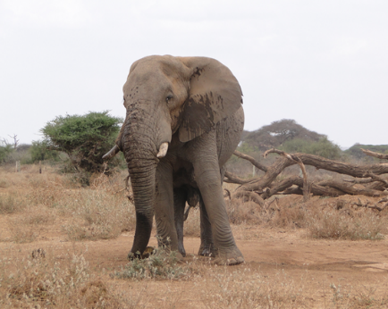Ecotourism is increasingly recognised for its multiple benefits to many economies, and assists visitors to see natural areas in a low-impact fashion. We offer a broad range of consulting services in the eco-tourism and leisure sectors for both established and emerging enterprises. Our focus is on providing solutions in product development, including exploring new frontiers of eco-tourism and leisure through feasibility studies and business development.

**Specialties**

* Consumer trends analysis and insights
* Facility audits, reviews and due diligence reporting
* Feasibility/programming studies –technical assistance
* Information systems and content creation
* Products pricing, market studies and business planning
* Project set-up, planning and impacts evaluation
* Public policy evaluation – impact studies & tourism statistics

**Projects development, monitoring and evaluation**

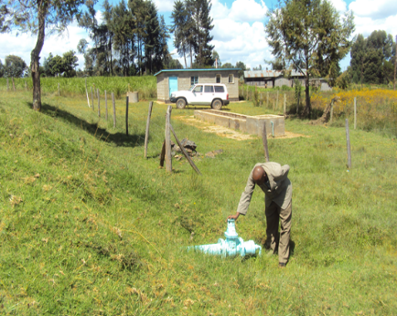We offer consulting services in project development and management for small and medium-sized projects. We support our clients' or customers' initiate, plan, execute, and control outputs that meet specific goals and ensure success. Our services are fully customisable to suit a client’s needs and often blend consultancy and capacity development. We support our clients with monitoring and evaluation of their projects, and implement project delivery approaches, taking into consideration risk assessments and analyses of critical project parameters.

**Specialties**

* Projects supervision and advisory on ecology and environmental matters
* Evaluation of projects proposals
* Project quality management and deliverables tracking
* Projects monitoring, evaluation and learning
* Projects resource mobilization advisory
* Technical and environmental due diligence (TEDD)

**Eco-business and enterprise development**

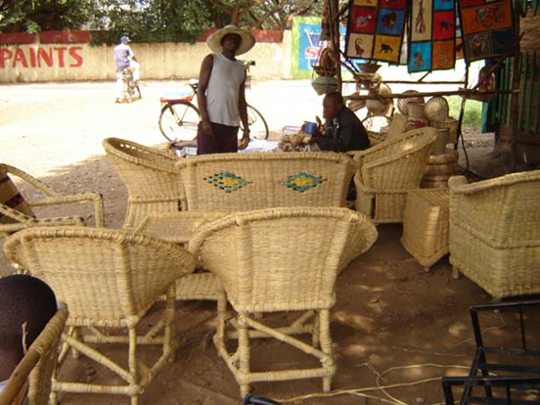We facilitate the rethinking of businesses to achieve sustainability and goals by offering services that increase profitability, drive innovation and efficiency through eco-business development and conservation, and environmental policy development and reviews. We promote businesses and enterprises across different sectors through the adoption of approaches that ensure greater ownership of the outputs; and are compliant with the relevant legislations.

**Specialties**

* Carbon/environmental footprint assessments
* Green business feasibility studies and products development
* Green products development and planning
* Utility (energy and water) audits and usage plans
* Waste reduction and recycling strategies and plans
* Business planning and feasibility studies
* Business value and block chains analyses
* Policy reviews

**Mining and mineral exploration**

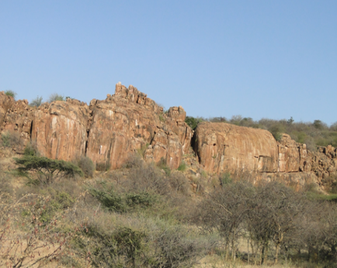Our consulting services are meant to support mining and mineral exploration in all aspects associated withresearch and resource mapping. We can assist at all stages of operations, from site investigation, planning, and rehabilitation, with the understanding that mining operations usually create a negative environmental impact, both during the operation and after the closure, including undertaking environmental, health, safety, and risk audits.

**Specialties**

* EHS audits and due diligence reporting
* Full planning applications for quarries and mining projects
* Geophysical and topographical surveys
* Resource mapping, assessment and feasibility studies
* Site closure and restoration advisory

**Documents reviews and editorials**

We offer a full range of reviews and editorials in ecology, biodiversity, social, economic, and environmental fields. Our reviews and editorials target both academic and non-academic materials from public and private sector entities.

**Specialties**

* Editing of documents in accordance with client’s styles
* Full manuscript review/editorial for peer-review publications
* Integrated and strategic plans reviews
* Management plans review
* Statistical data analyses
* Surveys and market research reports review

**Projects**

**Environmental assessments**

**Photo 2**

|  |  |  |  |  |
| --- | --- | --- | --- | --- |
| Date | Client | Title | Partner firm | Country |
| Sep. – Oct. 2022 | Kenya Puxin Renewable Energy Co. Ltd | Environmental and social impact assessment for the proposed development and operation of Aberdare Boutique Lodge at North Kinangop Forest Camp, Nyandarua County | N/A | Kenya |
| Mar. – Jun. 2022 | Equatoria Teak Company | Environmental and social assessments and reviews for sustainable forestry & agroforestry business for Equatoria Teak Company, South Sudan | Centric Africa Limited | South Sudan |
| Jul. – Aug. 2021 | Busia Chicken Limited | Environmental and social impact assessment (ESIA) for the proposed Tangakona Poultry Farm on LR No. Bukhayo/Busibwabo/6465, Tangakona Area, Busia County | N/A | Kenya |
| Every Apr. – May. 2017-2021 | Kenyatta National Hospital | Annual environmental audits for Kenyatta National Referral Hospital, Kenya (2017-2021) | N/A | Kenya |
| Different dates (2016-2020) | Rubis Energy Kenya | Annual environmental, health and safety (EHS) audits for Rubis Energy Kenya (formerly Kenol Kobil PLC) gas stations, depots and other hydrocarbon facilities in Kenya (2014-2020) | N/A | Kenya |
| May. – Jun. 2020 | M/s Isaac Chege Maina | Environmental and social impact assessment (ESIA) for residential apartment on LR No. 441/317, Ongata Rongai, Kajiado County | N/A | Kenya |
| Mar. – Apr. 2020 | M/s Aloyce Nyamweya Angwenyi | Environmental and social impacts assessment (ESIA) for residential development on LR No. 442/299, Ongata Rongai, Kajiado County | N/A | Kenya |
| May. – Jun. 2019 | Premier Camel Milk Limited | Environmental and social impact assessment for the proposed camel milk processing plant at Nanyuki Railway Station, Laikipia County | N/A | Kenya |
| Aug.-Sep. 2019 | Energy Plus Limited | Environmental impact assessment for the proposed biomass briquettes mini-processor on plot LR No. Kiambu/Limuru South/4885/52 in Rironi, Kiambu County | N/A | Kenya |
| Mar. – Jun. 2018 | Samburu County Government/European Union | Environmental and social impact assessment (ESIA) study for the proposed export abattoir at Nomotio LIC Farm, Maralal, Samburu County | N/A | Kenya |
| Oct. – Nov. 2018 | Kenya Urban Roads Authority (KURA) | Environmental and social impact assessment for the proposed rehabilitation and upgrade to bitumen standard of the 3rd Avenue in Eastleigh Estate, Nairobi County | Baraki International Limited | Kenya |
| Dec. 2017 – Mar. 2018 | Ameken Minewest Company Limited | Environmental and social impact assessment study for the proposed liquefied petroleum gas (LPG) storage and filling plant on LR No.27/Mwihoti/Githurai, Roysambu Sub-county, Nairobi County. | N/A | Kenya |
| Feb. – Mar. 2016 | M/s. Ali Mohamed Issah & Others | Environmental impact assessment report for the proposed stalls and flats on plot LR. No. 36/11/156 along 6th St., Eastleigh Estate, Nairobi County | N/A | Kenya |
| Oct. – Dec. 2016 | Nanak Body Builders Limited | Environmental impact assessment for the proposed mixed-use warehouse/offices on plot LR. No. 209/10625, Masai Road, Nairobi | N/A | Kenya |
| Oct. – Nov. 2016 | Bulal General Trading Co. Ltd | Environmental audit of pozzolana quarry on LR. No. KJD/Olooloitikoshi/Kitengela/345 | N/A | Kenya |
| Oct. – Nov. 2016 | Jirme Hotel and Resort, Marsabit County | Environmental and social impact assessment for the proposed tented campsite at Jirme Tourist Hotel, Marsabit County | N/A | Kenya |
| Dec. 2014 – Feb. 2015 | National Irrigation Authority | Annual environmental health and safety (EHS) audit for National Irrigation Authority Western Kenya Irrigation Schemes (Ahero, Bunyala, Katilu, Maugo, Perkerra and West Kano Irrigation Schemes), 2015 | ICPHER Consultants Co., Ltd. | Kenya |
| Sep. – Oct. 2015 | Emckan Investments Limited | Environmental impact assessment for the proposed residential apartment on LR No. 83/14/322, Umoja Estate, Nairobi County | N/A | Kenya |
| Jul. – Aug. 2015 | Kenya National Highways Authority (KeNHA) | Environmental and social impact assessment (ESIA) for the periodic maintenance of Kyumvi-Kaseve-Masii-Syongila Road, Machakos County | Smartway Holdings Ltd | Kenya |
| Nov.-Dec. 2015 | Kenya National Highways Authority (KeNHA) | Environmental and social impact assessment (ESIA) for the periodic maintenance of Quimbiso-Mandera Road, Mandera County | Smartways Holding Ltd | Kenya |
| Jun. – Jul. 2014 | M/s. Guracha Adi Bidu | Environmental impact assessment report for the proposed residential development on LR No. 118, Ole Kasasi, Ongata Rongai, Kajiado County | N/A | Kenya |
| Feb. – Mar. 2014 | Syldon & Partners Consulting Engineers Limited | Environmental impact assessment report for the proposed hostel block on LR No. Kisumu/Marera/3842, Kisumu County | N/A | Kenya |
| Oct. – Nov. 2013 | M/s. Ali Mohamed Issah & Others | Environmental and social impact assessment (ESIA) for the proposed construction of a shopping mall and residential apartments on plot no. LR/36/1/84, Eastleigh, Nairobi | N/A | Kenya |
| Oct. – Nov. 2013 | Pastoralist Community Initiative and Development Assistance (PACIDA) | Environmental impact assessment report for the proposed PACIDA office block on plot No. 562 in Marsabit Town, Marsabit County. | N/A | Kenya |
| Apr. – Jul. 2013 | Narupa Community Wildlife Conservancy | Environmental and social impacts assessment study for the proposed conservancy headquarters and ecotourism tented camp at Narupa Community Wildlife Conservancy, Isiolo County. | N/A | Kenya |
| Aug. – Oct. 2013 | Africa Oil Kenya B.V. | Environmental and social impact assessment (ESIA) for the proposed Bahasi - Sala access road, Isiolo County. | Earthview Geoconsultants Ltd | Kenya |
| Aug. – Oct. 2013 | Africa Oil Kenya B.V. | Environmental and social impact assessment (ESIA) for the proposed Laisamis–Bahasi access road Marsabit County. | Earthview Geoconsultants Ltd | Kenya |
| Nov./2012 - Jan./2013 | JICA ECORAD Project | Environmental and social impact assessment (ESIA) for water projects (Arapal, Dololo Dokatu, Dadach, Lekuchula, Satawesa and Yaa Gala water projects) in Marsabit County. | Nippon Kioei | Kenya |
| Jun. – Aug. 2013 | Kenya National Highways Authority (KeNHA) | Hydro-geological survey and environmental and social impacts assessment for the proposed twenty (20) water boreholes along Turbi-Marsabit-Merille Highway (A2) for the highway construction. | Midroc Drilling Company | Kenya |
| Nov. – Dec. 2012 | JICA ECORAD | Environmental and social impact assessment (ESIA) for the proposed Kalacha Goda feedlot project in Kalacha Location, Marsabit County. | Nippon Kioei | Kenya |
| Nov. – Dec. 2012 | JICA ECORAD Project | Environmental and social impact assessment (ESIA) for the proposed construction of livestock market in Dirib Location, Marsabit County. | Nippon Kioei | Kenya |
| Nov. – Dec. 2012 | M/s Ali Shariff Hussein Stone Quarry Services, Marsabit | Environmental and social impacts assessment of the proposed stone quarry on plot No. 689 in Jirme Location, Marsabit Central, Marsabit County. | N/A | Kenya |
| Oct. 2011 - Jan. 2012 | Asante Investment Company | Environmental and social impact assessment study report for the proposed Asante Safari Tented Camp, Talek Area – Narok County. | N/A | Kenya |

**Ecology and biodiversity**

Photo 3

|  |  |  |  |  |
| --- | --- | --- | --- | --- |
| Date | Client | Title | Partner firm | Country |
| Aug. 2024-Ongoing | Ministry of Environment and Forestry | Development of management plans for Nimule National Park and the Sudd Ecosystem, Republic of South Sudan | Eco-Consultancy Limited | South Sudan |
| Feb. 2024-On-going | Fujita Corporation/Katahira & Engineers International and Kenya National Highways Authority (KeNHA) | Ecological monitoring of ecosystems for the Mombasa Port Area Road Development Project – Packages 2 & 3. | N/A | Kenya |
| Apr. 2024-Nov. 024 | State Department for Wildlife, Kenya | Development of management plans for Mara Ripoi and Mbokishi Conservancies in the Mara Ecosystem | Centric Africa Limited | Kenya |
| Oct. 2023 – Feb. 2024 | Ministry of Wildlife Conservation and Tourism | Strengthening capacity for biodiversity and IWT information management systems for South Sudan. | N/A | South Sudan |
| May. 2022-2024 | Kenya National Highways Authority (KeNHA) and World Bank (IDA) | Biodiversity assessment of the Modogashe-Wajir road section and Lorian and Borji swamp ecosystems. | Centric Africa Limited | Kenya |
| Dec. 2021 - Mar. 2022 | Project Oil Kenya (POK) | Ecological baseline study for the proposed water pipeline (Turkwel Dam – Lokichar) for Project Oil Kenya in northern Kenya. | Earthview Geoconsultants Ltd | Kenya |
| Feb. - Mar. 2021 | Rift Valley Connect Consortium | Baseline ecological and small mammals’ assessments along the proposed Nairobi-Nakuru-Mau Summit road expansion project. | Norken International/FFMES/WSP Canada | Kenya |
| May.-Aug. 2020 | Aperture Green Power Company Limited | Ecological and biodiversity assessments for the proposed 50MW wind farm in Ndeiya Ward, Kiambu County, Kenya. | Happy Forest Limited/ALVUS ESG Consulting | Kenya |
| Dec., 2019 – Mar. 2020 | Themis/Hannan Arya Energy Limited | Baseline ecological and biodiversity baseline assessments for the proposed 40mw PV Solar Park in Dalalekutuk Area of Kajiado County, Kenya. | Happy Forest Limited/WSP South Africa | Kenya |
| Aug., 2019 – Apr. 2022 | Kenya National Highways Authority (KeNHA) | Ecological supervision, development and execution of mangrove restoration plan for the Mombasa Port Area Road Development Project (MPARD-Package 2). | Katahira & Engineers Consultants/Norken International | Kenya |
| Feb. – Mar. 2018 | Bechtel Corporation | Terrestrial biodiversity baseline study for the proposed Nairobi-Mombasa expressway project, Kenya. | Norken International/ERM | Kenya |
| 2016 | United Nations High Commission for Refugees (UNHCR) | Ecological impacts assessment for the for the proposed Kalobeyei Settlement, Turkana County. | Norken International | Kenya |
| Aug. – Sep. 2016 | Wildlife Clubs of Kenya | Ecological assessment and mapping of land degradation caused by quarrying activities in the Kitengela Wildlife Dispersal area of Nairobi National Park, southern Kenya. | N/A | Kenya |
| Jul. – Sep. 2016 | M/s Mercy Cheruto Kabeni/South Eastern University of Kenya | Mapping and assessment of the key drivers of land use and cover changes in Makueni County. | N/A | Kenya |
| Sep. 2015 - Jun. 2016 | Mawig Women Group | Land degradation, food security and livelihood assessment of households within the river Rageng catchment area. | Riana Development Network | Kenya |
| Feb. – Aug. 2015 | County Government of Isiolo | Ecological analysis and pre-feasibility assessment of wind energy investment sites in Isiolo County. | N/A | Kenya |
| Oct. 2013 – Feb. 2014 | Mara Siana Conservancy, Kenya | Development of Siana Mara Conservancy Management Plan, 2014-2019. | BEFA Consultants Limited | Kenya |
| Jun.-Sep. 2014 | County Government of Mandera | Baseline study and mapping of livestock routes and markets in Mandera County. | N/A | Kenya |
| Jun.. 2010 – Jun. 2011 | International START/GEC Secretariat (Ref: GEO-0627839 Capacity Building for Global Change - START Climate Change Award) | Land use and climate change: potential impacts on human socio-economic developments, biodiversity conservation and management of southern rift valley wetlands, Kenya. | N/A | Kenya |

**Resource economics**

Photo 5

|  |  |  |  |  |
| --- | --- | --- | --- | --- |
| Date | Client | Title | Partner firm | Country |
| Mar. – May. 2020 | Blueflag Services Limited | Feasibility study and value chain analysis for establishment of meat and dairy goat farm project in Mavoko Area, Machakos County, Kenya. | N/A | Kenya |
| Dec. 2016 - Apr. 2017 | County Government of Isiolo | Financial sources and investment opportunities in Isiolo County | Currentlinks Ltd | Kenya |
| Feb. – Jun. 2015 | County Government of Isiolo | Isiolo county socioeconomic baseline survey. | N/A | Kenya |
| Dec. 2014 - Mar. 2015 | County Government of Mandera | Pre-feasibility study for the establishment of regional livestock diseases control and diagnostic centre in Mandera County. | N/A | Kenya |
| Dec. 2014 - Mar. 2015 | County Government of Mandera | Pre-feasibility study for establishment of modern honey extractor and refinery in Mandera County. | N/A | Kenya |
| May. – Aug. 2014 | County Government of Marsabit | Feasibility study and value chain analysis for development and establishment of fish processing and cold storage facilities on the eastern shores of Lake Turkana, Marsabit County. | N/A | Kenya |
| Jul. – Sep. 2014 | County Government of Marsabit | Feasibility study and value chain analysis for the proposed multi-species abattoir in Marsabit County | N/A | Kenya |

**Water and sanitation**

**Photo 6**

|  |  |  |  |  |
| --- | --- | --- | --- | --- |
| Date | Client | Title | Partner firm | Country |
| Mar. 2015 – Mar. 2016 | Tanathi Water Services Board | Hygiene promotion and gender mainstreaming training, sanitation and waste water management action plan for Kitui and Yatta water service providers. | ICPHER Consultants Co. Ltd. | Kenya |
| Dec. 2015 – Jan. 2016 | J. Githinji & Associates | Hydro-geological survey and environmental and social impacts assessment for the proposed borehole on plot no. LR No. 3/22418 in Joska, Machakos County. | Everesta Ltd | Kenya |
| May. – Aug. 2015 | County Government of Kitui | Identification, environmental and spatial assessment of suitable sites for dams and sand dams construction in Kitui County. | N/A | Kenya |
| May. – Jun. 2012 | Kwale International Sugar Company Limited | Ground water assessment and foundation site investigation for Ramisi Sugar Farm- KISCOL. | N/A | Kenya |
| Jul. – Nov. 2011 | Water Resources Authority (WRA) | Surface and groundwater assessment and planning in respect to Isiolo County mid-term ASAL programme study 2011-2013 | N/A | Kenya |

**Energy**

**Photo 7 and 7.5**

|  |  |  |  |  |
| --- | --- | --- | --- | --- |
| Date | Client | Title | Partner firm | Country |
| 2020 | Property Development (Kenya) Limited, Nairobi, Kenya. | Energy audit for Property Development (Kenya) Limited, 2020 | Nanotech Engineering Limited | Kenya |
| 2020 | DHL Worldwide Express Limited, Nairobi, Kenya. | Energy Audit for DHL Worldwide Express Limited, 2020 | Nanotech Engineering Limited | Kenya |
| 2020 | Razco (LyonsMaid) Limited, Nairobi, Kenya. | Energy Audit for Razco (LyonsMaid) Limited, 2020 | Nanotech Engineering Limited | Kenya |
| Dec. 2017 - Mar. 2018 | Ameken Minewest Company Limited | Pre-feasibility study for proposed liquefied petroleum gas (LPG) storage/filling plant in Githurai, Nairobi County | N/A | Kenya |

**Occupational safety and health**

**Photo 8**

|  |  |  |  |  |
| --- | --- | --- | --- | --- |
| Date | Client | Title | Partner firm | Country |
| Different dates (2016-2020) | Rubis Energy Kenya | Annual occupational safety and health and fire safety audits of Rubis Energy (formerly Kenol Kobil PLC) gas stations, depots and other hydrocarbon facilities in Kenya (2016-2020). | N/A | Kenya |
| Dec. 2014 - Feb./2015 | National Irrigation Authority | Occupational safety and health and fire safety audits for the National Irrigation Authority schemes (Ahero, Bunyala, Katilu, Maugo, Perkerra and West Kano Irrigation Schemes) in western Kenya, 2015 | ICPHER Consultants Co. Ltd. | Kenya |

**Eco-tourism and leisure**

**Photo 9**

|  |  |  |  |  |
| --- | --- | --- | --- | --- |
| Date | Client | Title | Partner firm | Country |
| Nov. 2021 – Feb. 2022 | Kenya Wildlife Conservancies Association (KWCA) and WWF-Kenya | Feasibility assessment for the establishment of four conservancies (Darathe, Buluk, Elle-Dimtu and Dabel) in Marsabit County. | N/A | Kenya |
| Oct. – Nov. 2014 | County Government of Marsabit | Development of Marsabit County tourism information materials. | Netplug Communication Services | Kenya |
| May. – Jul. 2014 | County Government of Marsabit | Assessment and evaluation of existing and potential tourism facility investment sites in Marsabit County. | N/A | Kenya |

**Projects development, monitoring and evaluation**

**Photo 10**

|  |  |  |  |  |
| --- | --- | --- | --- | --- |
| Date | Client | Title | Partner firm | Country |
| Jun. – Aug. 2013 | Kenya Livestock Marketing Council | Development of project proposal on application of hydroponics technology for fodder production in northern Kenya as a climate change adaptation strategy; and livestock marketing information management system (E-LIMIS) for the Kenya Livestock Marketing Council (KLMC). | N/A | Kenya |
| Oct. – Dec. 2011 | Kenya Livestock Marketing Council | Monitoring and evaluation of co-management of livestock markets – the public and private partnership model for the management of livestock markets in nine (9) ASAL counties of Kenya (Baringo; Marsabit; Wajir; Garissa; Tana River; Isiolo; Turkana; Samburu; and Narok Counties). | N/A | Kenya |
| Aug. – Sep. 2011 | Ewaso Ng’iro North Development Authority (ENNDA) | Monitoring and evaluation of water infrastructure rehabilitation projects in four counties of northern Kenya (Isiolo; Nyandarua; Laikipia; and Nyeri Counties). | N/A | Kenya |

**Eco-business, enterprise, and policy reviews**

**Photo 4**

|  |  |  |  |  |
| --- | --- | --- | --- | --- |
| Date | Client | Title | Partner firm | Country |
| Sept. 2024-Ongoing | Maasai Mara Wildlife Conservancies Association | Development of solid waste management plan for the Mara Conservation Area landscape | N/A | Kenya |
| Sep. – Oct. 2021 | Green Minds of Africa (GMAf) | Profiling of fifteen (15) conservancies for nature-based enterprises investment in southern and northern Kenya. | N/A | Kenya |
| Apr. – Jul. 2020 | Kitui County Government | Development and review of Kitui County solid waste management policy. | Smartways Holding Ltd | Kenya |
| Apr.-Jul. 2020 | Kitui County Government | Development of Kitui County forestry and agro-forestry policy | Stratbest Ltd | Kenya |
| Oct. – December 2019 | Africa Meat Export Business Association (AMEBA) | Development of strategic plan (2019-2024) for Africa Meat Export Business Association (AMEBA). | N/A | Kenya |
| Sep. 2013-Sep. 2015 | Kenya Livestock Marketing Council | Development of business agenda and advocacy frameworks for engagement between business membership organizations and county governments in twelve (12) ASAL counties in Kenya. | N/A | Kenya |
| Oct. – Nov. 2014 | Turkana District Livestock Marketing Council | Development of livestock truck fleet management plan for Turkana County Livestock Marketing Council. | N/A | Kenya |

**Mining and mineral exploration**

**Photo 11**

|  |  |  |  |  |
| --- | --- | --- | --- | --- |
| Date | Client | Title | Partner firm | Country |
| Jul. – Sep. 2016 | Bisanadi Mining Company Limited | Mapping and inventory of blue sapphire, ruby, yellow sapphire, green and red garnets, emrod, chipstone and hematite exploration sites in Isiolo County. | N/A | Kenya |

**Documents reviews and editorials**

**Photo 12**

|  |  |  |  |  |
| --- | --- | --- | --- | --- |
| Date | Client | Title | Partner firm | Country |
| Oct. – Nov. 2017 | County Government of Samburu | Review and editorial of committee report on assumption of office of the Governor – Samburu County. | N/A | Kenya |
| Jul. – Sep. 2016 | County Government of Samburu | Review of the Samburu County Integrated Development Plan (CIDP), 2013-2017 | N/A | Kenya |

**Our clients**

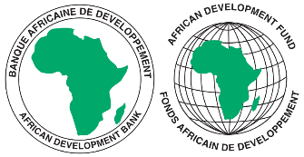****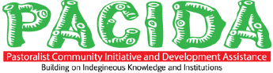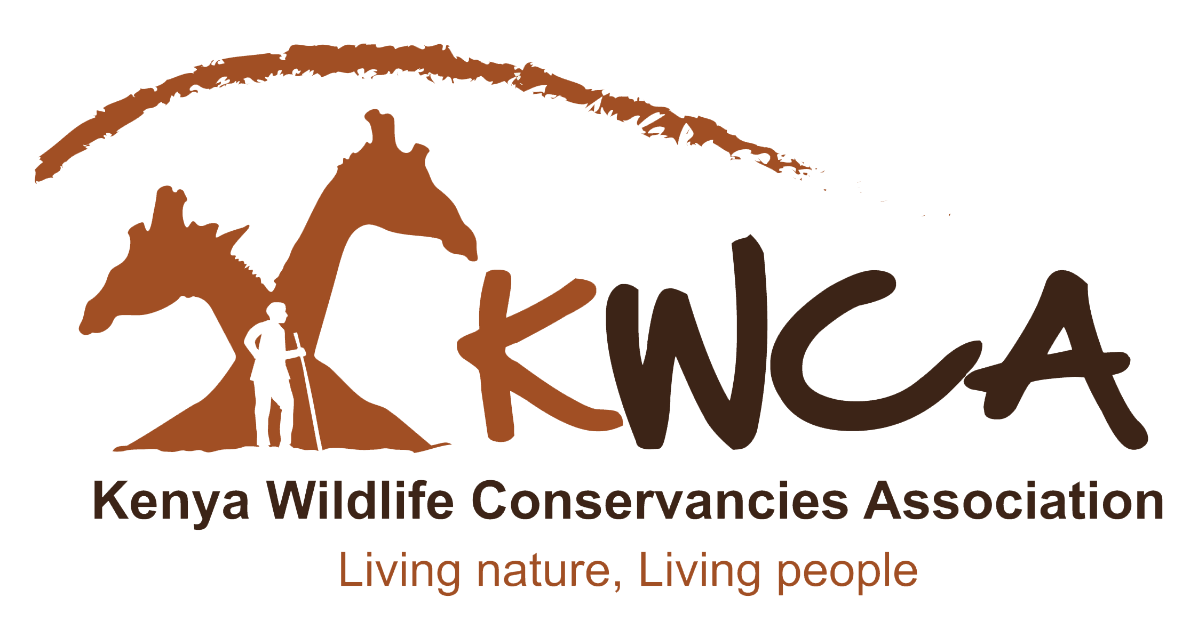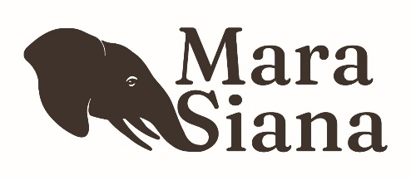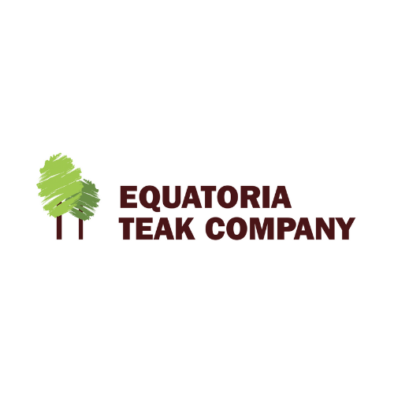

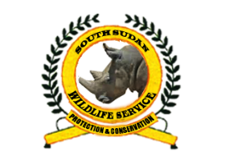 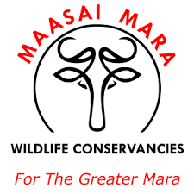 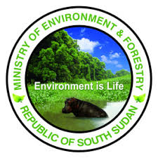

**Contacts**

**OIKOS VERITAS SERVICES LIMITED**

c/o West Park Towers, Suite 508, Mpesi Lane, Off-Muthithi Road, Westlands, Nairobi,

P.O. Box 35539-00100 Nairobi, Kenya

Tel: +254 799 000 399

Email address: info@oikos-veritas.co.ke

Website: www.oikos-veritas.co.ke